**DMM-SWITCH-ScanList Custom Device User Manual**

After installing the DMM-SWITCH-ScanList Custom Device, you will be able to add it from the System Explorer.

Adding the Custom Device

1. Create a New Project in VeriStand selecting File>>New Project
2. Name your project and select a place to save it.

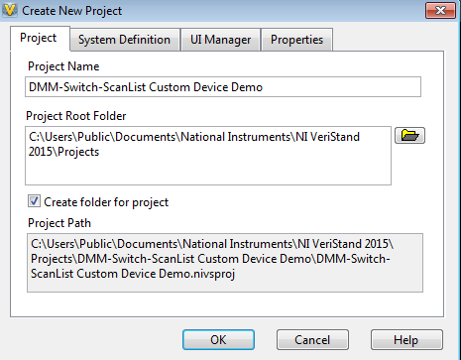

1. Expand the System Definition File item in the Project Explorer window.

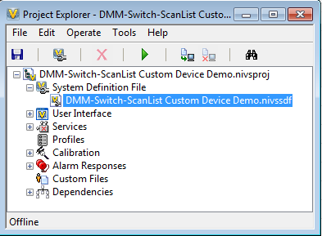

1. Double click your System Definition file (nivssdf) to open the System Explorer
2. Expand the Controller item to have access to the Custom Devices

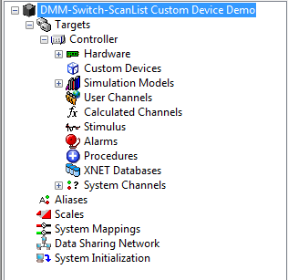

1. Right-click Custom Devices and select DMM-SWITCH-ScanList

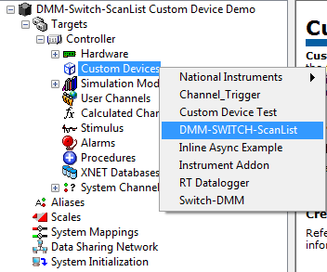

1. Expand the different sections to familiarize with the Custom Device.

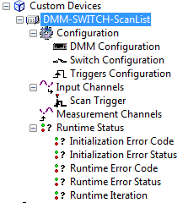

* **Configuration**: Consists of 3 configuration items (DMM Configuration, Switch Configuration, and Triggers Configuration) necessary to successfully execute your DMM-Switch ScanList task.
* **Input Channels:** The only Input Channel is the Scan Trigger. The Scan Trigger will be in charge of triggering a scanned measurement. The user can map the Scan Trigger to a Boolean control in your VeriStand User Interface to trigger a measurement for all the channels added under Measurement Channels.
* **Measurement Channels:** The output channels will be added depending in your configuration selections. The amount of channels particularly depends on your Switch Configuration.
* **Runtime Status:** These are output channels that will help you with additional information about the status of your Custom Device. You can map some Numeric Indicators in your VeriStand User Interface to this Runtime Status Channels to monitor the health of your Custom Device at Runtime.
  + **Initialization Error Code:** If an error occurs during the configuration of the Switch or the DMM, the acquisition loop won’t start and the user will be able to see the Error Code generated by the NI-Switch or NI-DMM. This is a numeric value that can be mapped to a Numeric Indicator in your VeriStand User Interface. This indicator can also show an Error Code when a Warning occurs. In this case, the Initialization Error Status should be 0 (False) and the acquisition loop will execute.
  + **Initialization Error Status:** If an error is generated during the configuration of the Switch or the DMM, the acquisition loop won’t start and the user will be able to see the Error Status generated by the NI-Switch or NI-DMM. This is a numeric value that can only take 0 or 1 as values. You can map this channel to a Boolean indicator in your VeriStand User Interface.
  + **Runtime Error Code:** If an error is generated during the execution of your scanned measurements, the acquisition will stop and you will have access to the Error Code though this numeric channel. This numeric channel can be mapped to a Numeric Indicator in your VeriStand User Interface.
  + **Initialization Error Status:** If an error is generated during the execution of your scanned measurements, the acquisition will stop and you will have access to the Error Code though this numeric channel. This is a numeric value that can only take 0 or 1 as values. You can map this channel to a Boolean indicator in your VeriStand User Interface.

1. We will explore